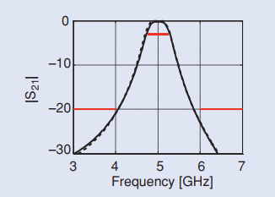Tapped line filter

Source: “Space Mapping”, Slawomir Koziel, Qingsha S. Cheng, and John W. Bandler

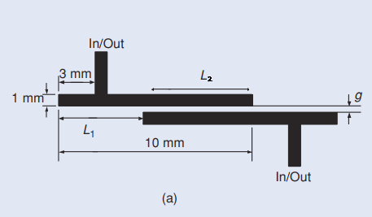

Pass-band filter

Design requirements:

|*S*21| ≥ -3 dB for 4.75 GHz ≤ *ω* ≤ 5*.*25 GHz

|*S*21| ≤ –20 dB for 3.0 GHz ≤ *ω* ≤ 4*.*0 GHz and 6.0 GHz ≤ *ω* ≤ 7*.*0 GHz

Obj1 = min(<4ghz) + min(>6 GHz) + 2\*max(4.75<f<5.25)

Cheap objective: minimize obj2 = L2 - L1

Initial parameters:

L1 = 6.977 mm, L2 = 3.02 mm , *g* = 0*.*060

dielectric constant *εr* = 100 mil

dielectric height *H* = 9.9

add line width as parameter

Parameter ranges

L1 = [6.5, 8] displacement between lines

L2 = [2.0, 3.5] coupling length between lines

g = [0.020, 0.1]

w = [0.8 1.2]

e = [8, 11]

h = [0.2, 0.4]